FORBES COLLEGE KSHETRAPUR-2, CHITWAN



Minor Project Final Report on

**“VOIP IMPLEMENTION OVER INTRANET”**

Submitted in Partial fulfillment of the Requirements for the **Bachelor of Computer Science (Hons NT and CS)** Submitted by:

|  |  |
| --- | --- |
| Name | Symbol Number |
| Bibek Poudel | 2102 |
| Bishal Chaudary | 2104 |
| Santosh Upadhyaya | 2112 |
| Suvash Shrestha | 2115 |

Supervised by**:**

Submitted to:

**Department of Cybersecurity and Networking**

2022

|  |  |  |  |  |  |  |  |  |  |
| --- | --- | --- | --- | --- | --- | --- | --- | --- | --- |
| CERTIFICATE This is to certify that the project report entitled **“VOIP IMPLEMENTION OVER INTRANET”** submitted by   |  |  | | --- | --- | | **Bibek Poudel** | **2102** | | **Bishal Chaudary** | **2104** | | **Santosh Upadhyaya** | **2112** | | **Suvash Shrestha** | **2115** |   in partial fulfilment of the requirements for the award of the **Degree of Bachelor of Computer Science (Hons) Networking and Cybersecurity** is a bonafide record of the work carried out under my guidance and supervision at Department of Networking and Cybersecurity, Forbes College. | |
| Signature of Supervisor  Rohan Kumar  Department of CS and NT  Forbes College |

# ACKNOWLEDGEMENTS

We feel immense pleasure and feel privileged in expressing our deepest and most sincere gratitude to our supervisor Rohan Kumar, for his excellent guidance throughout our project work. His kindness, dedication, hard work and attention to detail have been a great inspiration to us. Our heartfelt thanks to you sir for the unlimited support and patience shown to us. We would particularly like to thank him for all his help in patiently and carefully correcting all our manuscripts.

We are also very thankful to Er Sulav Adhikari, Operation Head in the Department of Networking and Cybersecurity for support and suggestions during our course of the project work in the third year of our undergraduate course.

Bibek Poudel (2102)

Bishal Chaudhary (2104)

Santosh Upadhyaya (2112)

Suvash Shrestha (2115)

**Table of Contents**

CERTIFICATE iv

ACKNOWLEDGEMENTS v

List of Figure v

LIST OF TABLES vi

LIST OF ABBREVIATIONS vii

ABSTRACT viii

CHAPTER ONE: 1

1.1 Background of study 1

1.2 Problem statement 2

1.3 Objectives 2

1.4 Scope 2

1.5 Limitation 3

CHAPTER TWO 4

2.1 LITERATURE REVIEW 4

2.2 History of Telephony 4

2.3 Voice over Internet Protocol (VoIP) 6

Table 2.1 VoIP Advantages and Disadvantages 7

2.4 VoIP components 8

2.5.1 VoIP Protocols 9

2.5.2 Real-Time Protocol (RTP) 9

2.5.3 Session Initiation Protocol (SIP) 9

CHAPTER THREE 10

RESEARCH METHODOLOGY 10

3.1 Proposed System 12

3.2 Introduction to Hardware Implementation 12

3.3 Development Tools and technologies used 13

3.3.1 Hardware 13

3.3.2 Software 13

3.4 Preparation Phase 14

3.4.1 Soft switch 14

3.4.2 Connection 16

4.1 Implementation and testing of the proposed system. 17

4.2 Integration of Hardware 21

4.3 Implementing the features of Asterisk Server 21

4.3.1 Voice Call 21

4.3.2 Create the extensions for the users 25

4.4 Configuration 28

4.4.1 Configuring LAN-VoIP user 29

4.4.2 Configuration of softphones (Micro sip and Linphone) 29

4.5 Testing of VoIP System 34

CHAPTER FIVE 38

5.1 Conclusion 38

References 39

# List of Figure

**Figure 1: Evolution of Telephones** 14

**Figure 2: Cisco PPDIOO Life Cycle** 18

**Figure 3: Proposed System Network architecture** 20

**Figure 4: Virtual Box** 24

**Figure 5: Creating a Virtual Machine for Kali Linux 64bit Server using Virtual Box.** 25

**Figure 6:Installation completed screen** 26

**Figure 7: Installation of Asterisk Server** 27

**Figure 8: Asterisk Status** 28

**Figure 9: Creating and configuring sip.conf and their peers** 31

**Figure 10: calling from client** 34

**Figure 11: Configuration of softphones (Micro sip and Linphone)** 37

**Figure 12: ATA user Configuration** 38

**Figure 13: : ATA usr conf** 40

**Figure 14: Ata usr rgistrd** 41

**Figure 15: Calling from x client to y client** 42

**Figure 16: Call ringing** 42

**Figure 17: Call establishment** 43

**Figure 18: Call termination** 43

# LIST OF TABLES

**Table 1.1 Gantt chart of Project Schedule 20**

# LIST OF ABBREVIATIONS

|  |  |
| --- | --- |
| **Abbreviations** | **Definition** |
| ACK | Acknowledge |
| ATC | Analogue Telephone Adapter |
| CLI | Command line Interface |
| FXS | Foreign Exchange Station (Port) |
| GUI | Graphical User Interface |
| GSM | Global System for Mobile (Communication) |
| IP | Internet Protocol |
| LAN | Local Area Network |
| PBX | Private Branch Exchange |
| PPDIOO | Prepare, Plan, Design, Implement, Operate, and  Optimize |
| PSTN | Public Switched Telephone Network |
| RTP | Real-time Transport Protocol |
| RTCP | Real-Time Control Protocol |
| SIP | Session Initiation Protocol |
| TCP | Transmission Control Protocol |
| QOS | Quality of Services |

# ABSTRACT

This study entails the simulation and implementation of voice over a data network, a telephony system using an IP PBX solution. A technology called voice over Internet Protocol (VoIP), or Internet telephony means that voice is carried over an IP network. Voice, which is an analogue signal, is converted to digital data, which is then disassembled and transmitted through a network only to be reconverted back to an analogue signal on the other end using a Linux based IP-PBX solution called Asterisk. This service can be properly managed and deployed over a network with less stress and expenses. The IP PBX main server also has integrated in its other communication services such as Voice mails, IVR’s, all embedded in the IP PBX SYSTEM. This technology promises an evolutionary leap beyond the standard telephone service we have been accustomed to, as well as a host of benefits. The new technology transmits voice signals the same way email is sent, using the Internet’s data-transfer protocols to break conversations into digital packets that can be sent on lower-cost, more efficient “packet-switched” networks. This project was able to address the persistent communication problem which existed in the departments by allowing users to communicate with the services the solution provided with less stress and comfort.

Target market includes: Corporate organizations, Universities, Health care, Airports, Hotels, Banks etc. This project is economic, cost effective, gives full control to the administrator and provides mobility, feasible, Peer-to-Peer phone calls. The contents of IP PBX System, supplemented by a good number of necessary and descriptive drawings which makes this project report very easy to understand.

# CHAPTER ONE:

# Background of study

**Introduction**

Video calling or voice calling through the use of the internet is a very common thing in today's world. Nevertheless, users have to pay charges directly or indirectly, tolerating all the delays even if you use the facility within the same network or sub-network. There are several drawbacks of using video calling over the internet within a small network such as delay of packets (travel to the main server outside network and reenter the same network again), direct or indirect costs, users need to be always connected online and efficiency and speed of the user's system vary according to connection quality and bandwidth. In this project, the Session Initiation Protocol (SIP), a client- server protocol, is used. SIP is a protocol for establishing a session between two or more parties. It is a call signaling and multimedia session control protocol used in applications for Voice, Video, and Messaging over IP networks.

This technology uses the Internet Protocol (IP) to transport voice signals over a data network. Instead of using the conventional analogue voice signal (sine wave signal), human speech is converted into a digital signal (1s and 0s) just like the data packets that travel through the data network. This technology uses the Internet Protocol (IP) to transport voice signals over a data network. Instead of using the conventional analogue voice signal (sine wave signal), human speech is converted into a digital signal (1s and 0s) just like the data packets that travel through the data network. We want to focus on the impact Internet Protocol (IP) telephony solution will have on the existing data network at Forbes College. This is helpful because transferring voice calls over data networks can save 75% or more compared to traditional telephone service. (Frost & Sullivan, 2007). With a detailed network infrastructure in place, it would not cost much to make calls through this existing data networks to reach telephones internally using existing telephone systems and methods of calling. Calls to a host not directly connected to the network can be made possible through the use of a gateways that connects a voice call to a public telephone network and allows for direct communications to future remote offices or external hosts due to expansion. VOIP PBX systems provide mobility to employees, flexibility when a business expands as they are much

easier to manage than the traditional PBX, and can also considerably reduce telephony administration costs

# Problem statement

Academic institutions like Forbes College are often challenged by the high cost and lack of flexibility of ordinary telephone systems. Often, there are many communication costs related to the management and implementations of programs for academic institutions. College employs the services of various telephone service providers. In fact, the issue of making calls internally through these service providers imposes a high monthly cost. Therefore, the aim of this project is to develop a communication technology to interconnect those hosts that are in the various departments at Forbes College. This solution will permit the IT department to deliver free telephone calls, voicemail, ring groups, call transfer, conferencing, IVR and other telephony services to both students and staffs internally.

# Objectives

The objectives of this project are to achieve the following:

* + - To develop an operational IP telephony solution for Forbes College, based on a software implementation of a telephone Public Branch Exchange (PBX) running a Linux distribution server Asterisk on the college data network.
    - Installation and configuration of an operational Linux server based on Asterisk using SIP Protocol.
    - Design a VoIP network to be utilized by the above server in which hosts can call each other with softphones, IP phones and also offering features such as voicemail.

# Scope

More specifically the study would detail an

* + - Installation and configuration of an operational Linux server based on Asterisk.
    - Design of a VoIP network to be utilized by the above server in which hosts (users) in different departments of the College can call each other internally with their audio enabled personal computers, softphones, IP phones and with traditional phones.

1.5 Limitation

There are still considerable technical challenges and limitation in implementing Voice over

Wi-Fi, including concerns about security and call quality. Wireless networks allocate bandwidth according to which devices are nearest to the WLAN access points, which can cause problems for voice call quality although some suppliers are developing systems that allocate bandwidth equally from the access points and can prioritize voice traffic using Quality of Service (QoS).

# CHAPTER TWO

# LITERATURE REVIEW

The first implementation of transmitting voice over the network was in 1973 through Network Voice Protocol (NVP) which was invented for Advanced Research Projects Agency Network (ARPANET). In 1990’s, there were a lot of VoIP applications that faced the problem of incompatibility due to fundamental differences between different vendors. Therefore, standards, specifications and interoperability guidelines were founded in May 1996 to standardize VoIP technology, which was a consortium of major equipment vendors and technology organizations including Cisco, Vocal Tec, 3Com, Microsoft, US Robotics and Net Speak.

It provides two distinct and independent services;

Call Routing: This is the process in which a name or phone number is being resolved into an IP address

CAC (Call Admission Control): It grants permission for a call setup attempt by determining if the network has enough bandwidth for the call.

* + - IP network: This can be a private network, an Intranet or the public network such as the Internet.
    - IP PBX: Internet Protocol private branch exchange (IP PBX) is a telephone switching system situated within the enterprise that switches calls between VoIP users on a local line while enabling users to share some certain number of external phone lines [2].

# History of Telephony

The first voice transmission, sent by Alexander Graham Bell, was accomplished on 10thMarch, 1876. It gradually evolved from a one-way voice transmission to a bi-directional voice transmission. Moving the voices across the wire requires a carbon microphone, a battery, an electromagnet, and an iron diaphragm and a physical cable between each location when a user wants to place a call.

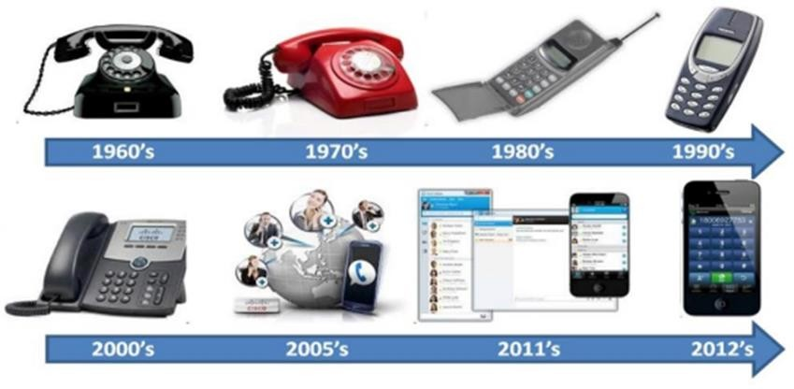

**Figure 1: Evolution of Telephones**

In the following paragraphs we focus on telephony network and the PBX that traditional telephone systems run on. The acronym PSTN stands for Public Switched Telephone Network. PSTN is the network that traditional phone systems used and was generally controlled by the telecommunication companies. This is the network our calls are travelling over when we pick up our handset and dial a number. This network spans the world and there are many different interfaces to it;

* + - POTS stand for Plain Old Telephone Service. It is commonly used for residential use. POTS is an analogue system and is controlled by electrical loops.
    - ISDN (Integrated Services Digital Network): This is a faster and more feature-filled connection (also more expensive). This gained some popularity within small to medium- sized businesses as a cost-effective way of connecting to the PSTN and getting some advanced services, like many lines to one office or voice and data lines on one service. ISDN is a digital service and offers a few more features over POTS (Barrie Dempster, 2006).
    - T1/E1 is a digital service used for high-volume data and voice networks and offers yet more features than ISDN, the most important feature being increased bandwidth that translates, in telephony, to more telephone lines (Kerry Garrison, 2006)

# Voice over Internet Protocol (VoIP)

Voice over Internet Protocol (VoIP) is one of the most important technologies in the world of communication. VoIP is simply a way to make phone calls through the internet. In other words, VoIP transmits packet via packet-switched based network in which voice packets may take the most efficient path. On the other hand, the traditional public switched telephone network (PSTN) is a circuit-switched based network which requires a dedicated line for telecommunications activity (J.B. Meisel, M. Needles, 2005). Furthermore, Internet was initially considered to transmit data traffic and it is performing this task really well. However, Internet is best effort network and therefore it is not sufficient enough for the transmission of real-time traffic such as VoIP. In addition, there are about 1 billion fixed telephone lines and 2 billion cell phones in the world that use PSTN systems. In the near future, they will move to networks that are based on open protocols known as VoIP (V. Mockapetris, 2006). That can be seen from the increasing number of VoIP users, for instance there are more than eighty million subscribers of Skype; a very popular VoIP commercial application (K. Dileep, A. Saleem and R. Yeonseung, 2008). VoIP has gained popularity due to the more advantages it offers than PSTN systems especially that voice is transmitted in digital form which enables VoIP to provide more features. However, VoIP still suffer few drawbacks which user should consider when deploying VoIP system

# Table 2.1 VoIP Advantages and Disadvantages

|  |  |
| --- | --- |
| **Advantages** | **Disadvantages** |
| * Low cost * Flexibility. * Provides voice mail and call forwarding. * Easy to implement and install * Free services gained usually when * connecting from PC to PC (G. Samrat, B.Sudeept, 2008) * Network Capacity utilization | * Users cannot make calls during power   outages.   * Connection limitation to emergency   services.   * Depends on Internet connection condition. * IP network that does not guarantee Quality * of Service for voice communication (J.M.Lozano-Gendreau,   A.Z. Halabi, M. |

|  |  |
| --- | --- |
| * Users can make VoIP calls from anywhere * for long distance or international calls. * Integration with other available services * over the Internet | Choueiri and V. Besong, 2006). |

# VoIP components

VoIP consists of three essential components: CODEC (Coder/Decoder), packetized and playout buffer (C. Lin, X. Yang, S. Xuemin and W.M. Jon, 2006). At the sender side, an adequate sample of analogue voice signals are converted to digital signals, compressed and then encoded into a predetermined format using voice codec. There are various voice codecs developed and standardized by International Telecommunication Union-Telecommunication (ITU-T) such as G.711, G.729, G.723.1a, etc.

Next, packetization process is performed which fragment encoded voice into equal size of packets. Furthermore, in each packet, some protocol headers from different layers are attached to the encoded voice. Protocols headers added to voice packets are of Real-time Transport Protocol (RTP), User Datagram Protocol (UDP), and Internet Protocol (IP) as well as data link layer header. In addition, RTP and Real-Time Control Protocol (RTCP) were designed at the application layer to support real-time applications. Although TCP transport protocol is commonly used in the internet, UDP protocol is preferred in VoIP and other delay-sensitive real-time applications. TCP protocol is suitable for less delay sensitive data packets and not for delay-sensitive packets due to the acknowledgement (ACK) scheme that TCP applies. This scheme introduces delay as receiver has to notify the sender for each received packet by sending an ACK. On the other hand, UDP does not apply this scheme and thus, it is more suitable for VoIP applications. The packets are then sent out over IP network to its destination where the reverse process of decoding and DE packetizing of the received packets is carried out. During the transmission process, time variations of packets delivery (jitter) may occur. Hence, a playout buffer is used at the receiver end to smoothen the playout by mitigating the incurred jitter. Packets are queued at the playout buffer for

a playout time before being played. However, packets arriving later than the playout time are discarded.

# VoIP Protocols

Voice over IP (VoIP) is the transmission of voice over network using the Internet Protocol. Here, we will introduce briefly be outlined the various VoIP Protocols that aided my project. The Protocols that provide basic transport (RTP), call-setup signaling (H.323, SIP was used) and QoS feedback (RTCP) (Clifford Stoll, 2009).

# Real-Time Protocol (RTP)

The Real-time Transport Protocol (RTP) is a network protocol for delivering audio and video over IP networks. RTP is used extensively in communication and entertainment systems that involve streaming media, such as telephony, video teleconference applications, television services and web-based push-to-talk features. This protocol is a user session protocol which relies on User Datagram Protocol (UDP), hence, make use of the checksums and multiplexing services to allow data handling for programs in real time unicast or multicast transmissions. RTP does not in itself guarantee real-time delivering of multimedia data. The tool that RTP uses to achieve real time transmissions is the Real Time Control Protocol (RTCP), which provides feedback about some control information. With this, it is possible to monitor the quality of the transmission and also possible to diagnose network problems. RTP consists of four main fields; RTP Payload type, Sequence number, Time Stamp, Source id.

In this project work, RTP is used as voice streaming protocol to send real-time traffic. To place a call on the data network, VoIP involves two types of protocol; call setup protocols and voice streaming protocols. Call setup protocols are available to serve as the VoIP signaling protocol, SIP, H.323 and IAX (Inter Asterisk exchange) are most common choices.

# Session Initiation Protocol (SIP)

SIP is an Internet Engineering Task Force (IETF) defined signaling protocol, widely used for controlling multimedia communication sessions such as voice and video calls over Internet Protocol. The protocol can be used for creating, modifying and terminating of multimedia communication sessions between end users. Session is considered to be a communication states kept between senders and receivers during communication.

# CHAPTER THREE

## **RESEARCH METHODOLOGY**

The methodology used in this study is the cisco lifecycle approach to network design and implementation. PPDIOO stands for Prepare, Plan, Design, Implement, Operate, and Optimize. PPDIOO is a Cisco methodology that defines the continuous life cycle of services required for a network (Stephen J. Occhiogrossp, 2011). The network lifecycle approach provides several key benefits aside from keeping the design process organized. These benefits include:

* It lowers the total cost of ownership by validating technology requirements and planning for infrastructure changes and resource requirements.
* It increases network availability by producing a sound network design and validating the network operation and improves business agility by establishing business requirements and technology strategies.
* It speeds access to applications and services by improving availability, reliability, security, scalability, and performance.

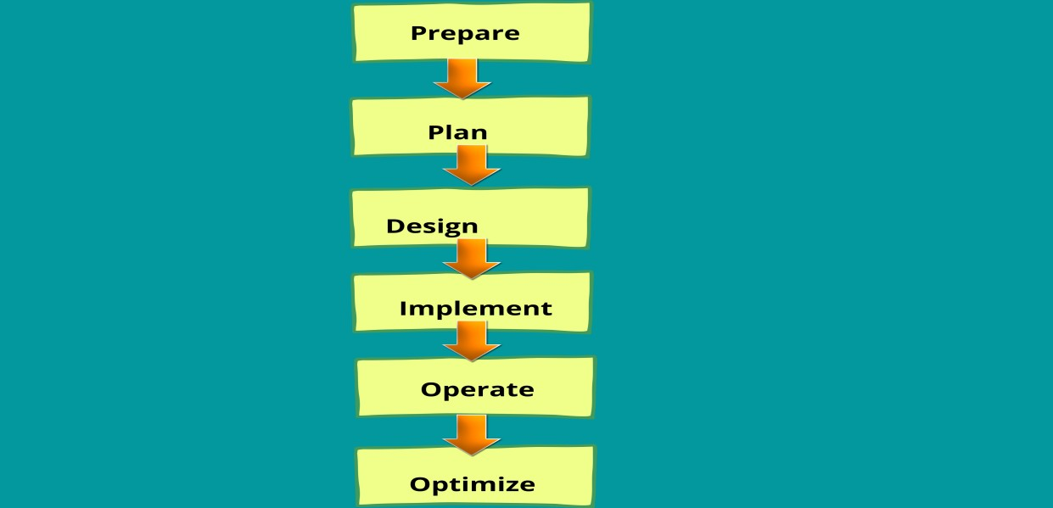

**Figure 2: Cisco PPDIOO Life Cycle**

***Prepare*** – This first prepare phase is not very technical at all. In fact, the primary purpose of this phase to justify the network upgrade.

***Plan*** – In this phase, we will audit the existing network, now depending on the type of project would consider what we are going to look at. A few things we could look at in an audit is to inventory all affected networking devices

***Design*** – This is where some of the fun begins. Based on the requirements (from the prepare phase) and the technical information (from the plan phase) we can begin designing the new network topology. The design we create in this phase will contain everything (IP Addressing, VLANs, Redundancy, Security, etc.) we are going to need for the project and be referenced throughout the rest of the project.

***Implement*** – As the title says, this is where the new equipment is configured and physically setup.

***Operate*** – The network has been deployed and is being utilized by the end users. Appropriate support personnel are also monitoring and maintaining the network. In this phase it is acceptable to perform software updates and monitor the overall health of the devices/links.

***Optimize*** – In this phase the network is proactively monitored & changed to improve performance or resolve issues. These changes can be minor or major depending on the amount and type of issues that occur. If the changes are big enough this life cycle could begin again back at the prepare phase.

It is worth noting that as part of the design phase of the PPDIOO methodology, a top-down approach is used, which begins with the organization’s requirements before looking at technologies. Network designs are tested and simulated a pilot or prototype network before moving into the implementation phase.

# Proposed System

The proposed solution will be implemented on Forbes College’s existing campus network to provide free voice calls between the various entities (i.e., student, staff, faculties, departments etc.) within the university. It will also allow them use of features like Voicemail. The service is secure and allows users to request for extensions to place calls. Additionally, all the calls are placed through the Linux based Asterisk PBX (Private Branch Exchange) which is in fact the core kernel. All calls are encrypted thereby prevents hackers to intercept an ongoing phone call.

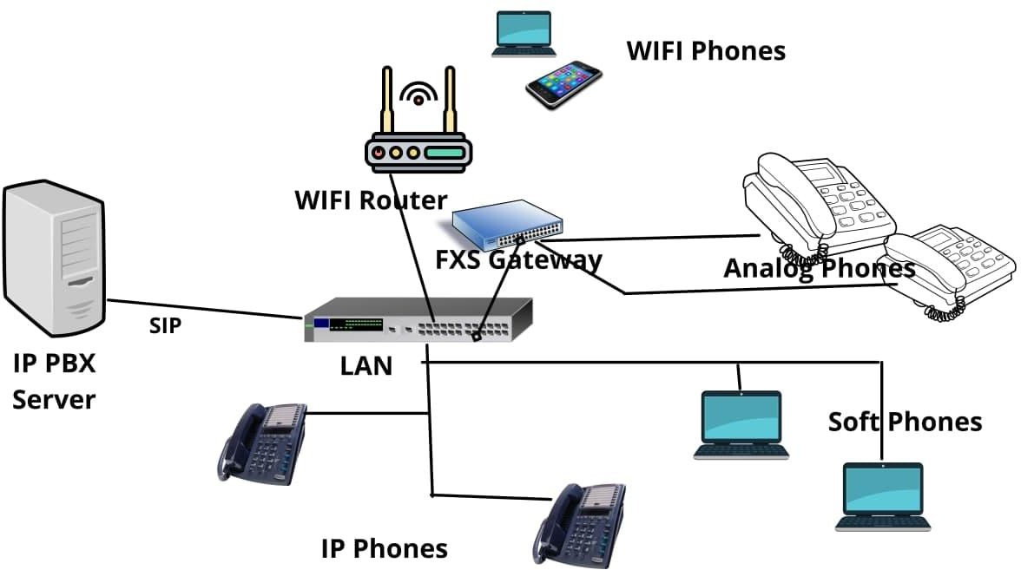

**Figure 3: Proposed System Network architecture**

# Introduction to Hardware Implementation

Implementation is the one of the important parts of this thesis. I will discuss about the implementation of Asterisk and also throw more lights on the hardware used in the configuration of all software. We will describe the features/components of the project. To configure eth0 or Ethernet card that has been installed on the server, and then select enable IP4 support, and finally enter the IP Address and IP Gateway. After installation of server and soft phone now we are going to integrate ATA with our IPPBX server. Configuring all VoIP users through the Asterisk server whether it is IP telephone or Softphone by creating SIP account for them.

# Development Tools and technologies used

There is the list of equipment’s listed here used for the simulation to a final completion of this project. There is combination of software, hardware and the open sources libraries.

# Hardware

The different hardware used in the system can be seen in Table 3.1 the table contains the specifications and brief description of the tools used in this project.

* + - * IP PHONE
      * FXS GATEWAY
      * ANALOG TELEPHONE
      * PC SERVER IP_PBX
      * WIRELESS ROUTER
      * LAPTOP
      * LAYER 2 SWITCH
      * CAT 5E
      * SMART MOBILE PHONE DEVICES

# Software

* + - * Linux
      * Asterisk
      * Soft phones software: Micro Sip and Linphone

# Preparation Phase

The prepare phase of the Cisco PPDIOO lifecycle approach to network design for a VoIP solution at Forbes College will necessitate the usage of all resources of the College.

# Soft switch

Soft switch is a central device in a telecommunications network which connects telephone calls from one phone line to another, across a telecommunication network or the public Internet, entirely by means of software running on a general-purpose system. Most landline calls are routed by purpose-built electronic hardware however, soft switches using general purpose servers and VoIP technology are becoming more popular.

Nowadays, many telecommunications networks make use of combinations of soft switches and more traditional purpose-built hardware. (Buckley and Sean, 2013)

A soft switch is also a VoIP server, providing a soft switch platform with full IP PBX call features. The most difference from IP PBX is its enormous numbers of users. After thorough review into platforms, we could use in developing IP telephony solution. We settled on an open-source framework called Asterisk.

**What is Asterisk?**

Asterisk is an open-source framework for building communications applications. Asterisk turns an ordinary computer into a communications server. Asterisk powers IP PBX systems, VoIP gateways, conference servers and other custom solutions. It is used by small businesses, large businesses, call centers, carriers and government agencies, worldwide. Asterisk is free and open source. Asterisk is sponsored by Digium (Asterisk.org, n.d). Today, there are more than one million Asterisk-based communications systems in use, in more than 170 countries. Asterisk is used by almost the entire Fortune 1000 list of customers. Most often deployed by system integrators and developers, Asterisk can become the basis for a complete business phone system, or used to enhance or extend an existing system, or to bridge a gap between systems.

**Where did Asterisk Come from?**

The Asterisk project started in 1999 when Mark Spencer released the initial code under the GPL open-source license. Since that time, it has been enhanced and tested by a global community of thousands. Today, Asterisk is maintained by the combined efforts of Digium and the Asterisk community.

**What Can You Do with Asterisk?**

Asterisk is a framework for building multi-protocol, real-time communications applications and solutions. Asterisk is to real time voice and video applications as what Apache is to web applications: the underlying platform. Asterisk abstracts the complexities of communications protocols and technologies, allowing you to concentrate on creating innovative products and solutions. You can use Asterisk to build communications applications, things like

business phone systems (also known as PBXs), call distributors, VoIP gateways and conference bridges. Asterisk includes both low and high-level components that significantly simplify the process of building these complex applications. See the Asterisk Applications section for more examples.

What informed us choosing Asterisk for Forbes College?

Asterisk became a preferred platform to develop IP telephony solution for Forbes College because it is open source, which means you can get under the source code, see how it works and make any changes or enhancements you like. Asterisk is flexible and lets you define the solution that truly fits your requirements. Asterisk is stable, reliable and in production on thousands of systems worldwide. Asterisk is free to use. But the framework itself is built by developers for developers. If one wants to create applications and solutions with Asterisk you will need a working knowledge of Linux, script programming, networking and telephony.

How Asterisk Works.

Asterisk is a hybrid TDM and packet voice PBX

* + - * Interfaces any piece of telephony hardware or software to any application
      * Prime components: channels and Extensions.conf - the Asterisk dial plan
      * Channels can be many different technologies - SIP, IAX, H323 etc.
      * extensions.conf is basically a programming language controlling the flow of calls
      * Applications do the work - answer a channel, ring a channel, voicemail.

# Connection

The medium used by the Lan-VoIP user is to connect to the server via the Intranet. Users can connect to Asterisk IP-PBX server via the LAN Intranet wherever they may be on campus.

**CHAPTER FOUR**

# Implementation and testing of the proposed system.

The implementation phase is very important for this project. A compromise between the ideal set- up for this project and what is realizable with the available equipment must be found, but nevertheless, the ideal project set-up must not be forgotten, to keep it as close to reality as possible. For the actual implementation a (Revised) step-by-step plan was chosen. The implementation stage is divided into two sections, namely the installation and configuration.

A server installation and configuration process are initiated on an Oracle Virtual Machine software called virtual box.

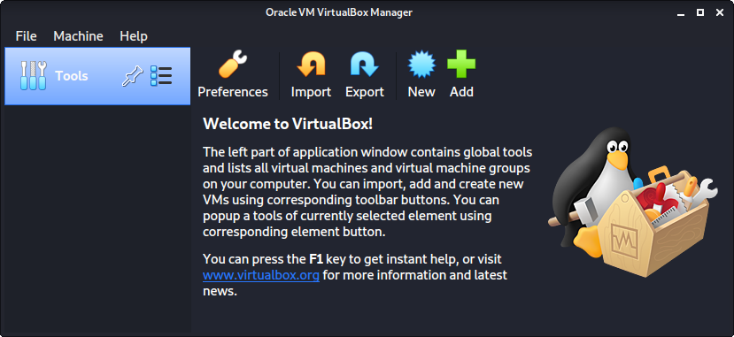

**Figure 4: Virtual Box**

* + 1. **Download and Installation of Kali Linux Server**

A 64bit version Linux based Kali Linux Operating System is used. The process begins with the installation of Linux based Kali Linux on the Virtual Machine as shown below:

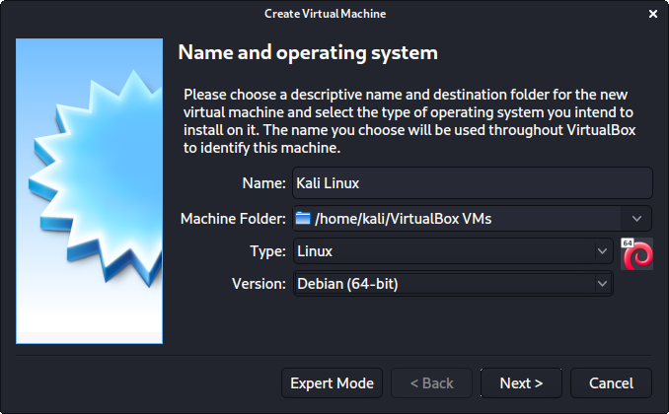

**Figure 5: Creating a Virtual Machine for Kali Linux 64bit Server using Virtual Box.**

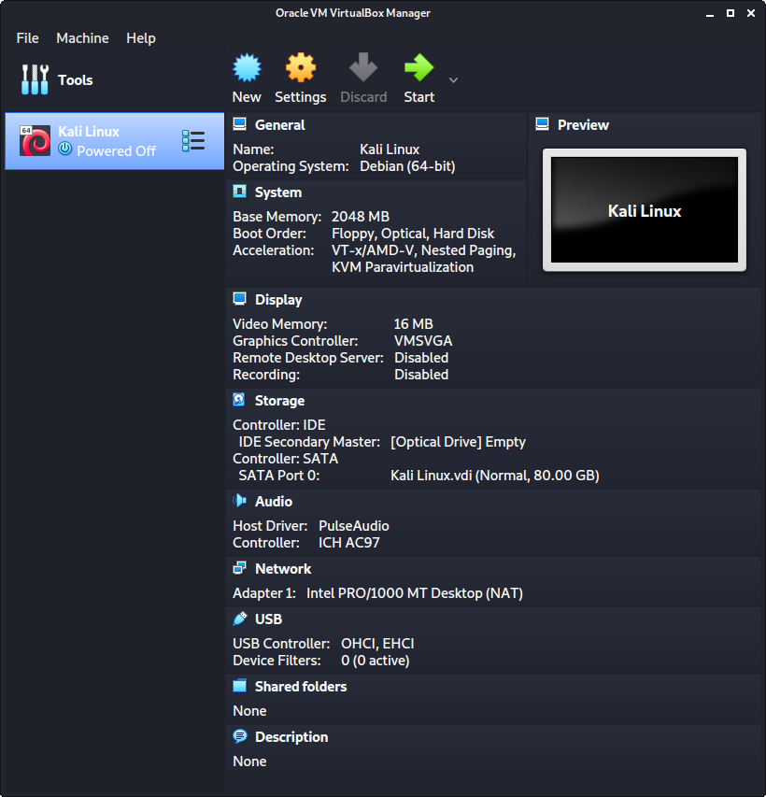

**Figure 6:Installation completed screen**

* + 1. **Download and Installation of Asterisk server**
* For this install we used Asterisk 18
* Before you begin the install process you will want to be sure that you server OS is up to date.

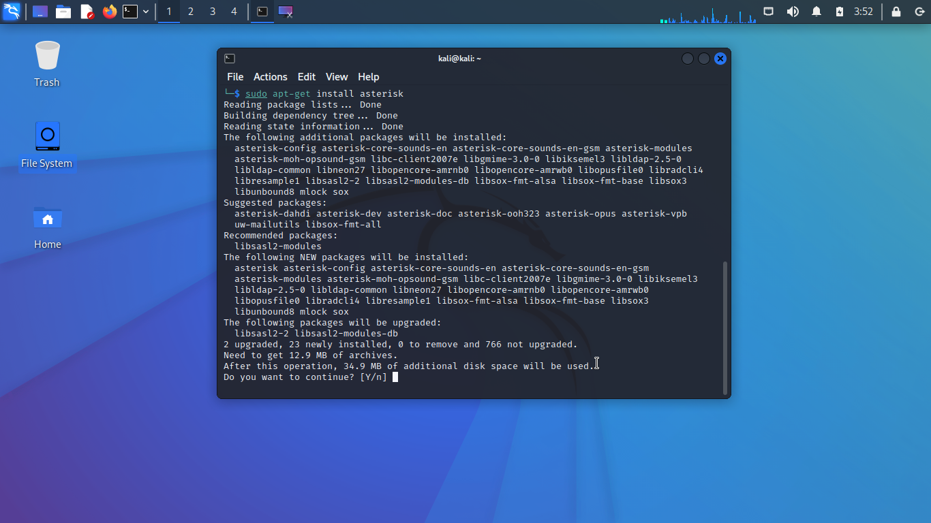

**Figure 7: Installation of Asterisk Server**

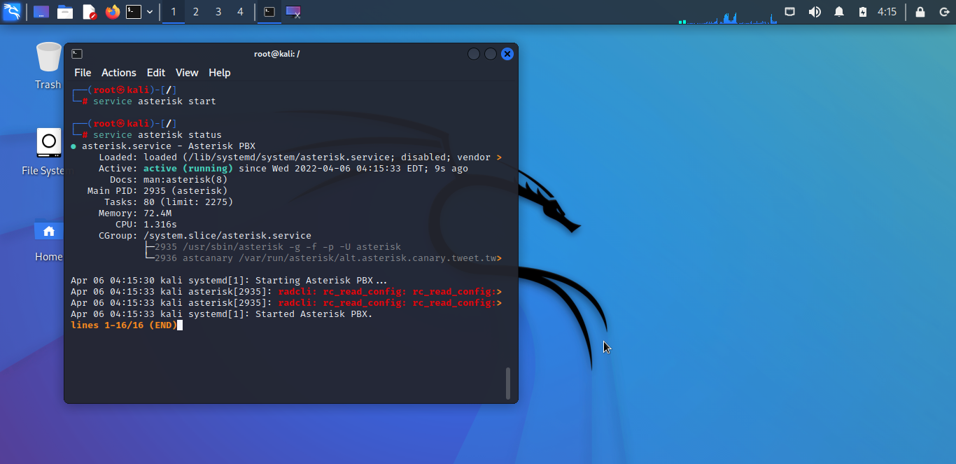

**Figure 8: Asterisk Status**

# Integration of Hardware

Integration is the next step after installation of the Asterisk server. Analogue phones are going to be integrated using ATA with our IP PBX server.

# Implementing the features of Asterisk Server

# Voice Call

The voice call is the basic property of unified communication system, voice call is based on SIP protocol. Communication is only allowed for those who are registered with the sip server. Communication devices can work on voice feature to provide good sound quality. Now Asterisk is installed and running so we are going to create 6 new users with their extensions and their voicemails.

For creating seven clients, we added the following commands in the sip.conf files which we have

downloaded along with the asterisk server. They are as below -

***sip.conf***

[general]

videosupport=yes

context=internal

allowguest=no

allowoverlap=no

bindport=5060

bindaddr=0.0.0.0

srvlookup=no

disallow=all

allow=ulaw

allow=alaw

allow=speex

allow=gsm

allow=h261

allow=h263

allow=h263p

alwaysauthreject=yes

canreinvite=no

nat=yes

session-timers=refuse

localnet=10.0.0.0/255.0.0.0

[7001]

type=friend

host=dynamic

secret=7001

context=internal

[7002]

type=friend

host=dynamic

secret=7002

context=internal

[7003]

type=friend

host=dynamic

secret=bibek

context=internal

[7004]

type=friend

host=dynamic

secret=7004

context=internal

[7005]

type=friend

host=dynamic

secret=7005

context=internal

[7006]

type=friend

host=dynamic

secret=7006

context=internal

[7007]

type=friend

host=dynamic

secret=7007

context=internal

***Voicmail.conf***

[main]

7001 => 7001

7002 => 7002

7003 => 7003

7004 => 7004

7005 => 7005

7006 => 7006

7007 => 7007

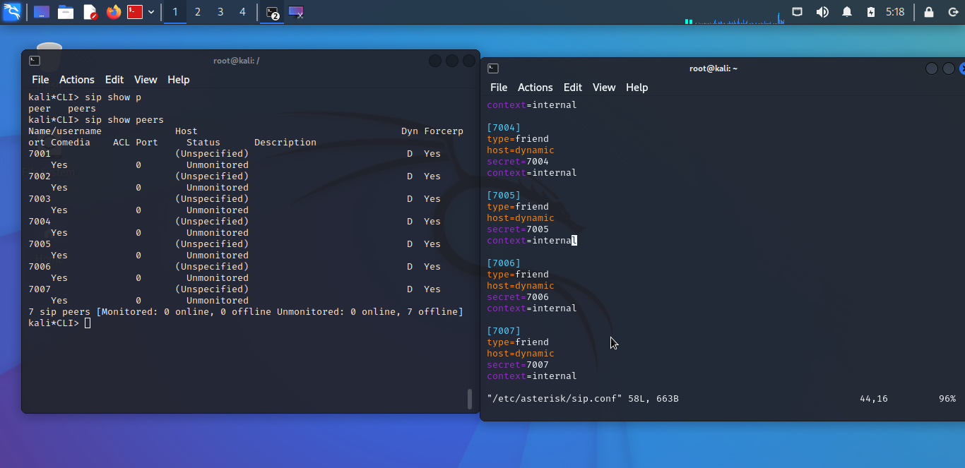

**Figure 9: Creating and configuring sip.conf and their peers**

# Create the extensions for the users

To create the extensions for the users we need to modify the file extensions.conf. If we dial the number (let x) we should contact Forbes college Front desk and if we dial the number (let y) we should contact the registry office. Other registered users can use their respective extensions to communicate.

***Extensions.conf***

[internal]

exten => 7001,1,Answer()

exten => 7001,2,Dial(SIP/7001,60)

exten => 7001,3,Playback(vm-nobodyavail)

exten => 7001,4,VoiceMail(7001@main)

exten => 7001,5,Hangup()

exten => 7002,1,Answer()

exten => 7002,2,Dial(SIP/7002,60)

exten => 7002,3,Playback(vm-nobodyavail)

exten => 7002,4,VoiceMail(7002@main)

exten => 7002,5,Hangup()

exten => 7003,1,Answer()

exten => 7003,2,Dial(SIP/7003,60)

exten => 7003,3,playback(vm-nobodyavail)

exten => 7003,4,VoiceMail(7003@main)

exten => 7003,5,Hangup()

exten => 7004,1,Answer()

exten => 7004,2,Dial(SIP/7004,60)

exten => 7004,3,Playback(vm-nobodyavail)

exten => 7004,4,VoiceMail(7004@main)

exten => 7004,5,Hangup()

exten => 7005,1,Answer()

exten => 7005,2,Dial(SIP/7005,60)

exten => 7005,3,Playback(vm-nobodyavail)

exten => 7005,4,VoiceMail(7005@main)

exten => 7005,5,Hangup()

exten => 7006,1,Answer()

exten => 7006,2,Dial(SIP/7006,60)

exten => 7006,3,Playback(vm-nobodyavail)

exten => 7006,4,VoiceMail(7006@main)

exten => 7006,5,Hangup()

exten => 8001,1,VoicemailMain(7001@main)

exten => 8001,2,Hangup()

exten => 8002,1,VoicemailMain(7002@main)

exten => 8002,2,Hangup()

exten => 8003,1,VoicemailMain(7003@main)

exten => 8003,2,Hangup()

exten => 8004,1,VoicemailMain(7004@main)

exten => 8004,2,Hangup()

;exten => 8005,1,VoicemailMain(7005@main)

;exten => 8005,2,Hangup()

exten => 8005,1,VoicemailMain(7006@main)

exten => 8006,2,Hangup()

After modified the extension file, we reloaded the asterisk server to save the changes which we made. This is done by typing the reload command. We now call one client to another by dialing the user id and also capture the packets through Wireshark. Here we are calling from client with id 7001 to 7002.

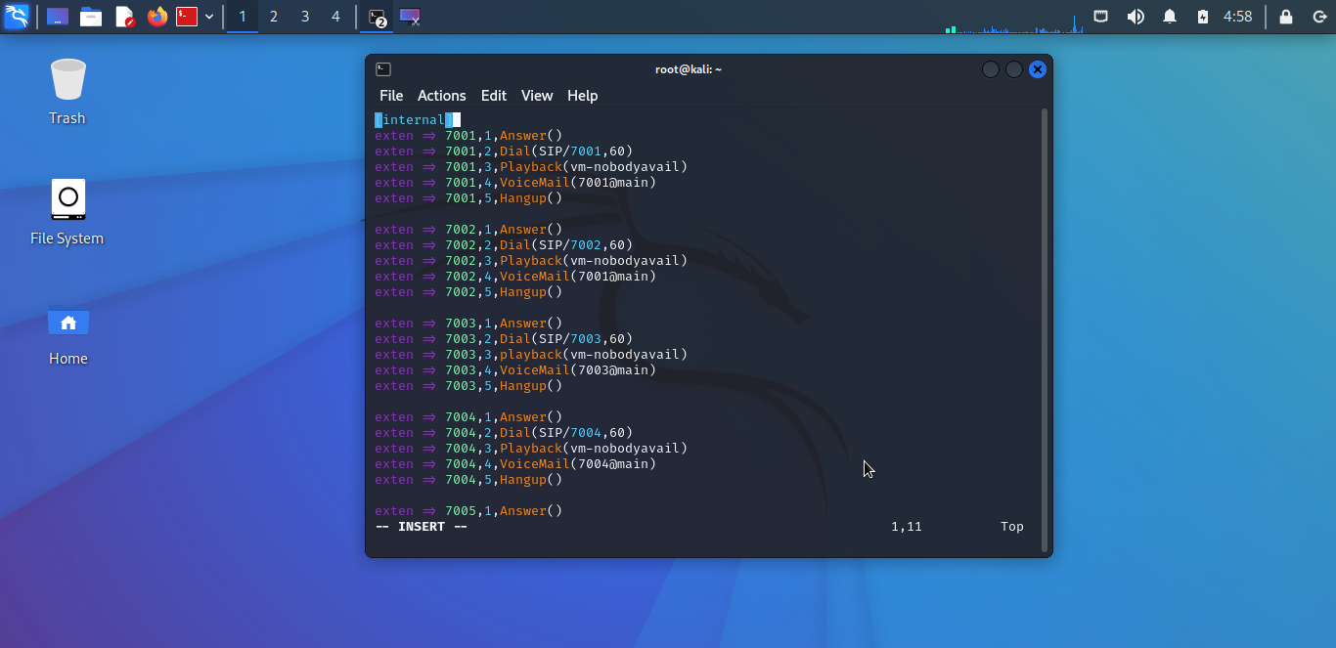

**Figure 10: calling from client**

# Configuration

Asterisk server configuration will be done via a CLI console, which demands knowledge of Linux to configure. Configuration is carried out also in accordance with the purposes of the Forbes College.

# Configuring LAN-VoIP user

Configuring all LAN-VoIP users through Asterisk server whether it is IP telephone or analogue telephone adapter by creating SIP account for them. All communication devices communicate through SIP protocol and all communication devices appear like LAN-VoIP users for Asterisk server.

# Configuration of softphones (Micro sip and Linphone)

ACCOUNT SETTINGS & SIP CREDENTIALS:

Account name: Compulsory entry which is the name of the extension given you by admin. Caller ID: User defined detailing you ID

Extension: Unique extension number with which users can call given by Admin ID: Same as the extension

Password: SIP authentication Password

*Settings are applicable to both Desktop and mobile/smart device.

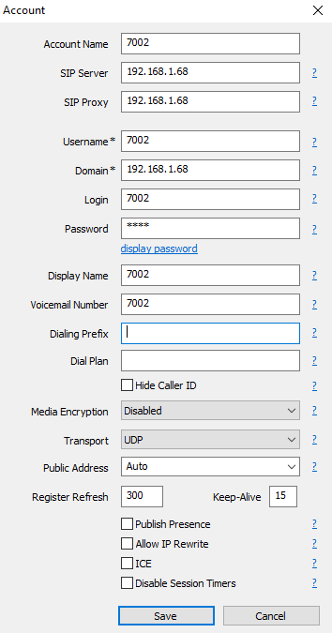

**Figure 11: Configuration of softphones (Micro sip and Linphone)**

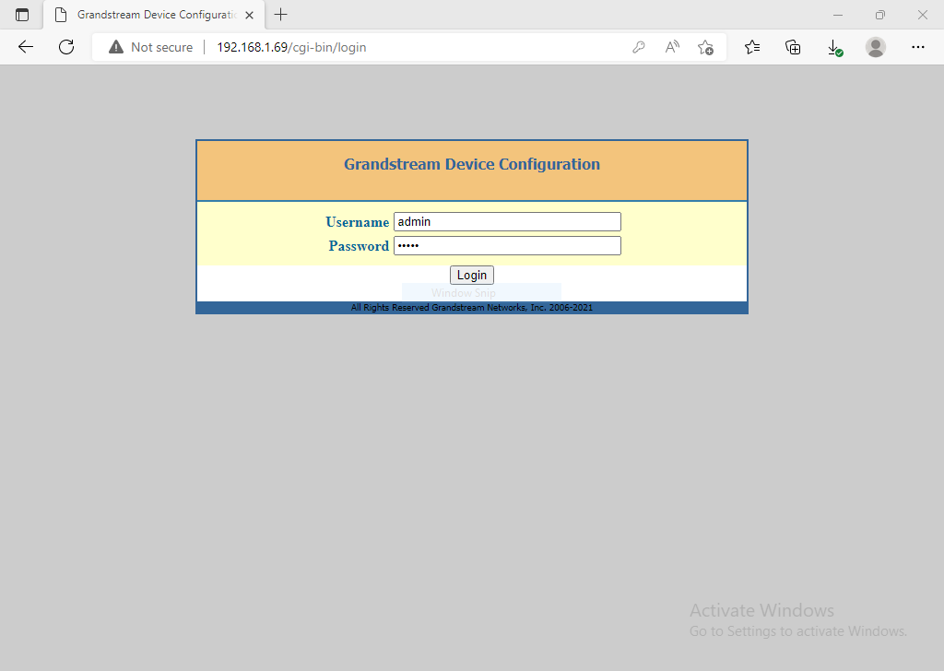

**Figure 12: ATA user Configuration**

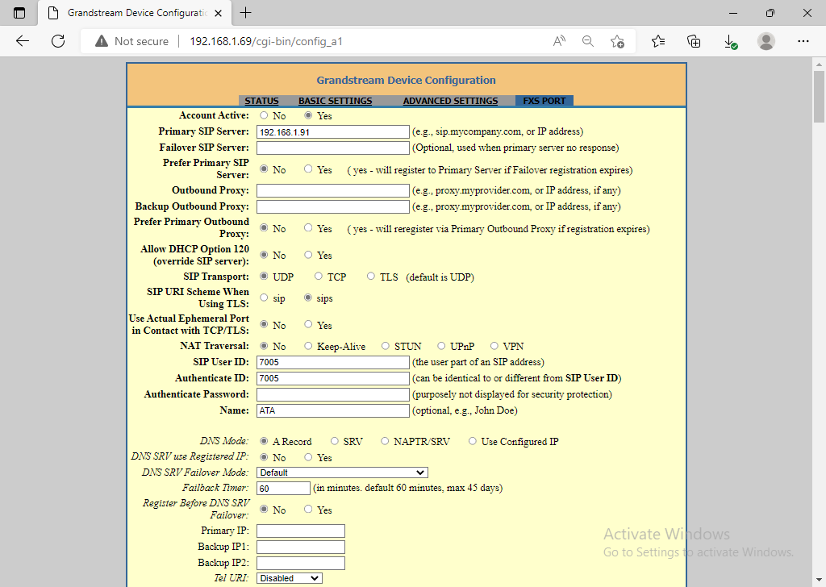

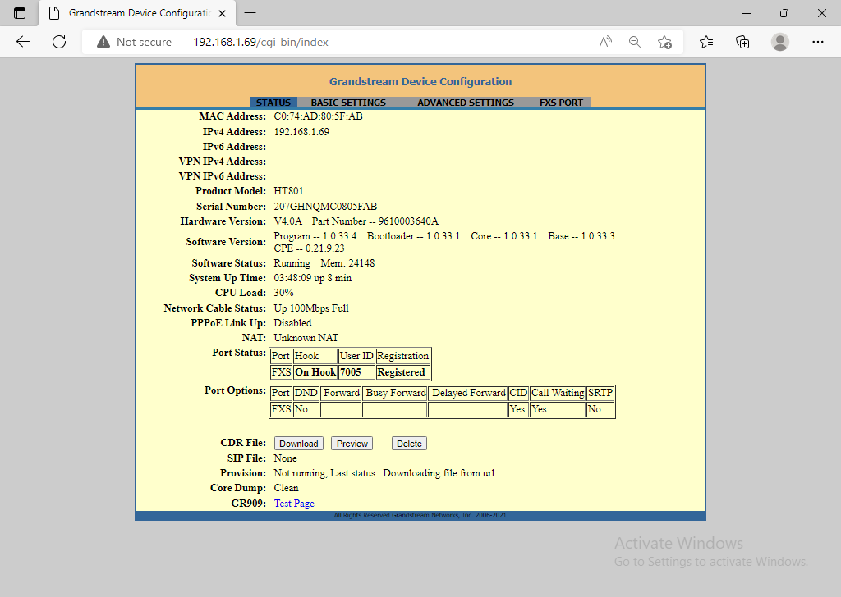

**Figure 13: ATA usr conf**

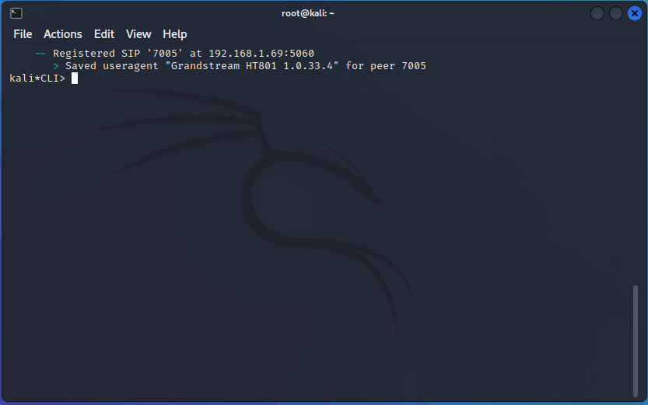

**Figure 14: ATA usr rgistrd**

# Testing of VoIP System

In this section we present ways in which testing of the deployed VoIP server would be conducted. Softphones on PCs and laptops will send registration request to the VoIP server, such that they can be registered and used while making calls.

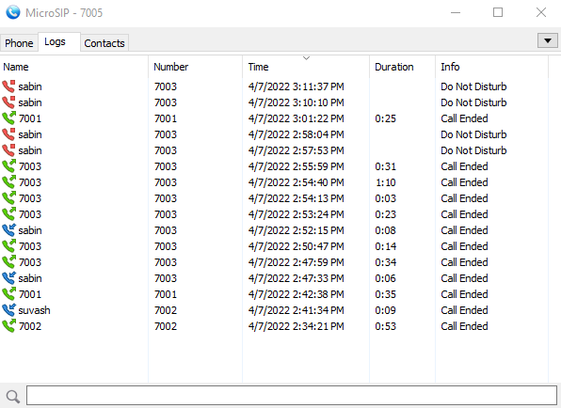

**Figure 15: Calling from x client to y client**

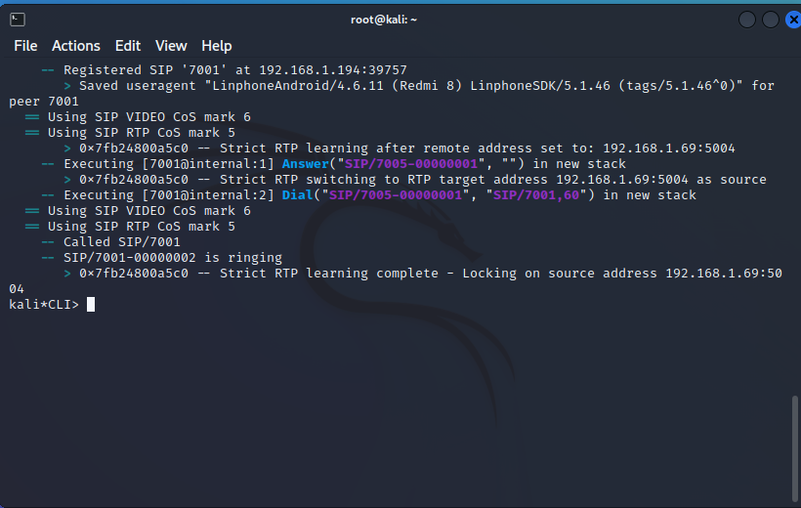

**Figure 16: Call ringing**

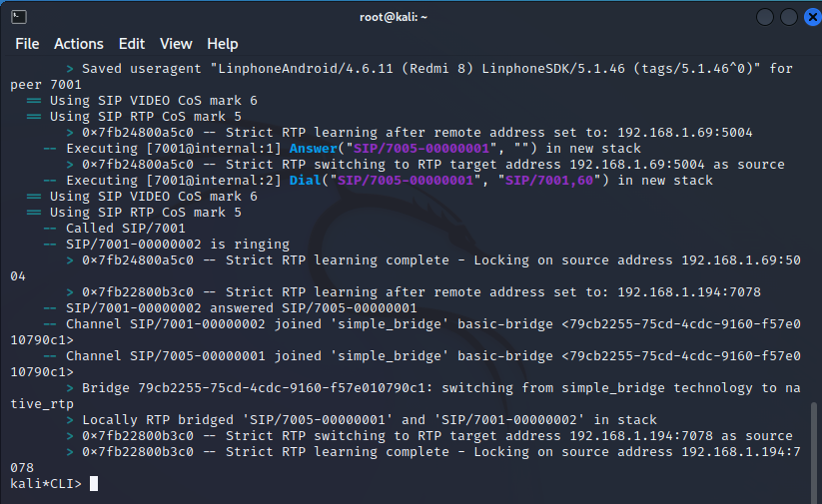

**Figure 17: Call establishment**

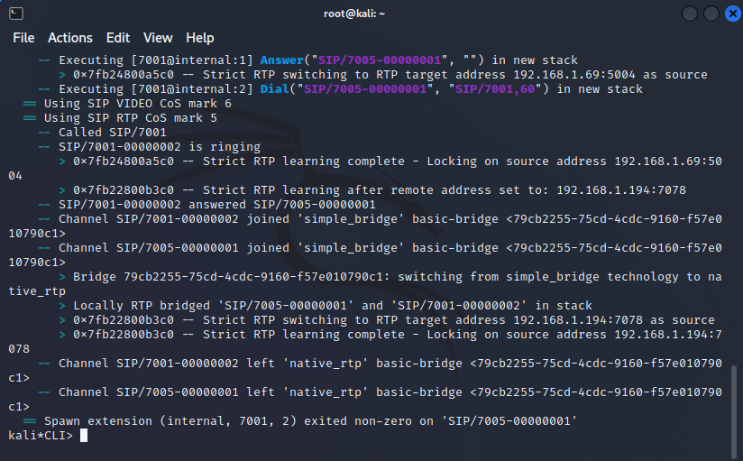

**Figure 18: Call termination**

**MoS VALUE CALCULATION**

● Mean Opinion Score (MoS) is a measure which is used representing the overall quality of a system.

● MoS value is the result of underlying network attributes and is extremely useful in accessing the call quality.

● It is a commonly used measure for the quality of audio, video and audiovisual entities.

➢ In our experiment we have pinged two users and then calculated the MoS value.

● Also, since we are pinging through a LAN connection, so the packet loss is Zero or near to zero, which means a perfect transmission over the connection to the two entities

# CHAPTER FIVE

|  |  |  |  |  |  |  |  |  |
| --- | --- | --- | --- | --- | --- | --- | --- | --- |
| Work | Week  1 | Week 4 | Week 6 | Week 8 | Week 9 | Week  12 | Week  14 | Week  16 |
| Study and  Research |  |  |  |  |  |  |  |  |
| Proposal  Writing |  |  |  |  |  |  |  |  |
| Consulting  Teachers |  |  |  |  |  |  |  |  |
| Midterm  Presentation |  |  |  |  |  |  |  |  |
| Coding,  Simulation and Testing |  |  |  |  |  |  |  |  |
| Final Report  Writing |  |  |  |  |  |  |  |  |

**Table 1.1 Gantt chart of Project Schedule**

# Conclusion

The objective of this project is to provide a VoIP system that the Forbes college can use to interconnect its users (student and staffs). The provided system is based on Asterisk; Asterisk was created in 1999 by Mark Spencer of Digium. Like any PBX, it allows attached telephones (hard phones & softphones) to make calls to one another, and to connect to other telephone services including the public switched telephone network and permit to deliver other VoIP services like voicemail, video calls, queuing, call parking& transfer and conferencing call.

# References

* + 1. Hersent, O., Gurle, D. and Petit, J., 2005. *Beyond VoIP protocols*. Chichester: Joh Wiley and Sons.
    2. Azam, W., 2021. *Cisco PPDIOO | A Network Life Cycle - W7cloud*. [online] W7cloud. Available at: <<https://w7cloud.com/cisco-ppdioo/>>
    3. Boucadair, M., 2009. “Inter-Asterisk Exchange (IAX): Deployment Scenarios in SIP Enabled Networks”.
    4. SearchUnifiedCommunications. 2021. What is VoIP (voice over Internet Protocol)? Definition from SearchUnifiedCommunications. [online] Available at:

<<https://www.techtarget.com/searchunifiedcommunications/definition/VoIP>>

* + 1. Asterisk. 2021. Get Started ⋆ Asterisk. [online] Available at:

<<https://www.asterisk.org/get-started>/>